/\* PROGRAM STATEMENT: Demonstrate single fork() system call \*/

#include<stdio.h>

#include<unistd.h>

int main()

{

//CALLING FORK TO CREATE A CHILD PROCESS

fork();

printf("Hello World\n");

return 0;

}

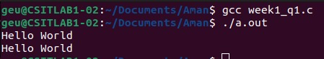

/\* PROGRAM STATEMENT: Demonstrate multiple fork() system call. \*/

#include<stdio.h>

#include<unistd.h>

int main()

{

//CALLING FORK TO CREATE A CHILD PROCESS

fork();

printf("Hello \n");

//CALLING FORK TO CREATE A CHILD PROCESS

fork();

printf("World \n");

//CALLING FORK TO CREATE A CHILD PROCESS

fork();

printf("Hello World\n");

return 0;

}

